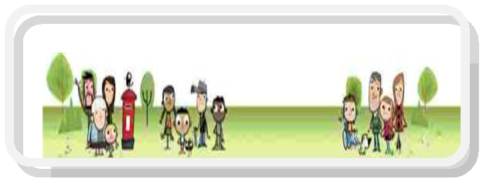

Solution Focused Triage Team DSPL9
Supporting Children, Young People & Families in Early Years, Schools, Colleges & at Home
For Watford, Three Rivers, Bushey & Radlett
Young Person Service Request – AGED 18+
Please complete and return to enquiries@dsplarea9.org.uk
Date of Enquiry
Your Name
Date of Birth
E-Mail Address
Telephone Number

Name of Parent (if consent for contact is given)
Home Address
Parent/home contact number
School/Setting/ College/Workplace:

What help do you need?
Required information: what services have previously or are currently involved or pending
Name of Service | Contact details (please give consent for contact)
Anything else you would like to tell us
Current Diagnosis:
Diagnosis Pending:

Information Sharing & Consent Statement

In order for us to provide services to you and your family more efficiently, we may need to share the information that you provide with organisations and services already working with you along with new services identified. Whilst carrying out an assessment of need we may identify other appropriate services in which cases we would provide support in referring to these services and share appropriate information as required to ensure that you receive the best services possible.

We are obliged to share information if there are any concerns about the safety and/or wellbeing of a child, young person or adult and there are clear reasons for doing so that are in the best interests of the child, young person or adult.
Statement

I______________________________ agree to the sharing of information between relevant organisations and services as appropriate. I understand that any information gathered regarding my family is recorded and will be securely stored and used for the purpose of providing services to my family. Information may also be used for monitoring and auditing the quality of the service(s) offered to myself, children and/or family. Confirmation of Consent (please tick and initial all entries)

 | YES | NO
I agree to the sharing of information between organisations and
Services working with my family in connection with the Triage Service
I agree that my contact details can be securely kept by DSPL9 and used to inform me of opportunities and events
Are there any organisations, services or individuals that you do not wish information to be shared with?
If your answer is yes please provide specific details:

Name | Signature | Date

Please return the completed form along with supporting information and documents to enquiries@dsplarea9.org.uk
Many thanks

Office use only
Actions Required | By Whom | Date

