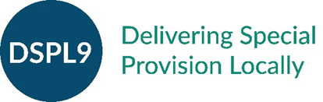
Solution Focused Triage Team DSPL9
Supporting Children, Young People & Families In Early Years, Schools, Colleges & at Home
For Watford, Three Rivers, Bushey & Radlett

SERVICE REQUEST FORM Tier 2
Behaviour Partnership

Guidance: IMPORTANT
We will initially apply a triage technique to ensure you are accessing the most appropriate tier of support. Please provide us with as much information as possible including information at tier 1-in house school support. We will contact you as soon as possible to discuss the case. Should you prefer to discuss this pathway please contact: Jenny Morley 0208 428 4571 or e-mail: head@warrendell.herts.sch.uk. Thank you.

Service Request Details
Name of person completing the request
Position
Name of Organisation:
Address:
Contact Number
e-mail address

Support requested
Organisation | Year group/s | Types of supporttransition/environment/ resources/ visit to hub school/ choice of language/ deescalation etc
Generic teacher support
TA support
MSA support
NQT support
New TA induction

Please give a brief description of support and outcomes to date (tier 1) Please attach your school behaviour policy to this request
(continue on a separate sheet if required)

Please give a brief description of the desired outcomes from behaviour partnership tier 2

Service Request signed by _______________________ (Print name) ______________________________( signature)

Date: _________________
Jenny Morley Lead head teacher for Primary Behaviour DSPL9 Warren Dell Primary School. Head@warrendell.herts.sch.uk

