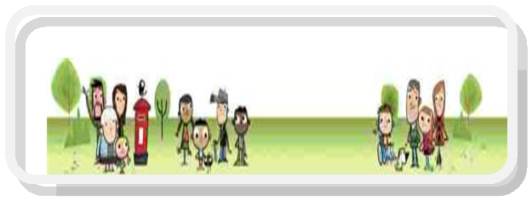

Solution Focused Triage Team DSPL9
Supporting Children, Young People & Families in Early Years, Schools, Colleges & at Home
For Watford, Three Rivers, Bushey & Radlett
GP/CAMHS Triage Service Enquiry

Date of Enquiry
Source of Enquiry (Practice)
Name of Contact/ Role
Telephone Number
E-Mail Address

Name & Date of Birth for Person of Concern
NHS Number/PARIS ID
Parent (s) name(s)
Home Address
Contact Number(s)

Brief Overview of Concerns

Has a risk assessment been carried out that identifies any of the following:
Significant/ moderate/ low risk to self: YES NO
Significant/moderate/low risk to others: YES NO
Please provide a copy of the risk management plan and any other relevant details. Many thanks
REQUIRED :Services Involved | Contact details
 | Other Information
Current Diagnosis:
Diagnosis Pending:
Information Sharing & Consent Statement

In order for us to provide services to you and your family more efficiently, we may need to share the information that you provide with organisations and services already working with you along with new services identified. Whilst carrying out an assessment of need we may identify other appropriate services in which cases we would provide support in referring to these services and share appropriate information as required to ensure that you receive the best services possible.

We are obliged to share information if there are any concerns about the safety and/or wellbeing of a child, young person or adult and there are clear reasons for doing so that are in the best interests of the child, young person or adult.
Note to professionals: Confirmation in writing of verbal consent for contact is acceptable
Statement

I______________________________ agree to the sharing of information between relevant organisations and services as appropriate. I understand that any information gathered regarding my family is recorded and will be securely stored and used for the purpose of providing services to my family. Information may also be used for monitoring and auditing the quality of the service(s) offered to myself, children and/or family. Confirmation of Consent (please tick and initial all entries)

 | YES | NO
I agree to the sharing of information between organisations and
Services working with my family in connection with the Triage Service
I agree that my contact details can be securely kept by DSPL9 and used to inform me of opportunities and events
Are there any organisations, services or individuals that you do not wish information to be shared with?
If your answer is yes please provide specific details:

Name | Signature | Date

Please return the completed form along with supporting information and documents to enquiries@dsplarea9.org.uk

Office use only
Actions Required | By Whom | Date

